MediaQ:
Crowdsourced Mobile Media Management System
Abstract
User generated video content is experiencing significant growth which is expected to continue and further accelerate forming Big Data in social media. MediaQ is a novel online media management system to collect, organize, share, and search mobile multimedia contents using automatically tagged geospatial metadata. User generated-videos can be uploaded to the MediaQ from users’ smartphones, iPhone and Android, and displayed accurately on a map interface according to their automatically sensed geospatial and other metadata. The MediaQ system provides the following distinct features. First, individual frames of videos (or any meaningful video segments) are automatically annotated by objective metadata which capture four dimensions in the real world: the capture time (when), the camera location and viewing direction (where), several keywords (what) and people (who). We term this data W4-metadata and they are obtained by utilizing camera sensors, geospatial and computer vision techniques. Second, a new approach of collecting multimedia data from the public has been implemented using spatial crowdsourcing, which allows media content to be collected in a coordinated manner for a specific purpose. Lastly, flexible video search features are implemented using W4 metadata, such as directional queries for selecting multimedia with a specific viewing direction.
This talk is to present the design of a comprehensive mobile multimedia management system, MediaQ, and to share our experience in its implementation. Our extensive real world experimental case studies demonstrate that MediaQ can be an effective and comprehensive solution for various mobile multimedia applications.

Bio
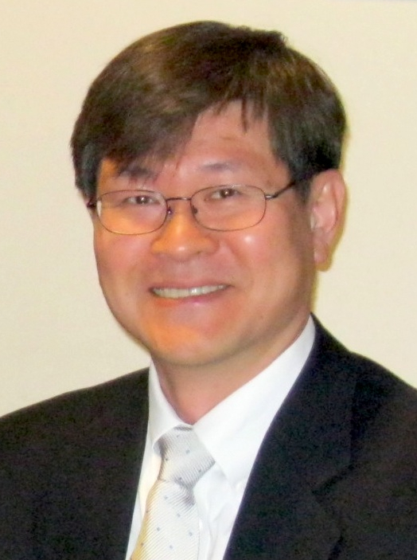
Dr. Seon Ho Kim is currently working as an Associate Director in the Integrated Media Systems Center (IMSC) at the University of Southern California. Before joining IMSC, he worked at the University of Denver and the University of the District of Columbia as faculty for eleven years. He received his BS degree in Electronic Engineering from the Yonsei University, Seoul, Korea in 1986. He also received his MS in Electrical Engineering and Ph.D. in Computer Science from the University of Southern California, California, in 1994 and 1999, respectively.

Dr. Kim's primary research interests include multimedia systems, databases, GIS, and mobile video data management, where he has more than 70 publications including a textbook, major journal papers, and top conference papers. He has been serving the research community as conference program committee member, journal editorial board member and reviewer.

